**Rock identification using deep convolution neural network**

**1. Introduction:**

***1.1Overview:***

The identification of rock type in the field would aid geological surveying, education, and automatic mapping. Its application here has effectively identified rock types from images captured in the field. It proposes an accurate approach for identifying rock types in the field based on image analysis using deep convolutional neural networks. The results show that the proposed approach based on improvement in intelligent rock-type identification and solves several difficulties facing the automated identification of rock types in the field.

***1.2Purpose:***

The aim of this project is to identify the rock types based on image analysis using deep convolutional neural networks.

**2. Literature Survey:**

***2.1 Existing Problem:***

The material that makes up the solid parts of Earth is known as rock. Igneous rock forms when magma (molten rock below the surface of the Earth), or lava (molten rock on the surface of the planet, cools and hardens). Sedimentary rock forms when sediment deposits that form when rocks, mineral crystals, and organic matter have been broken into fragments, called sediments. Metamorphic rock forms when existing rock is altered by changes in temperature, by changes in pressure, or by chemical processes. We identify rocks and minerals through a few physical tests such as Color, Streak, Luster, Cleavage, Fracture, Hardness, Mohs hardness scale, Crystal Shape, Density and grade level.

***2.2 Proposed Solution:***

The identification of rock type by the naked eye is effectively an image recognition task based on knowledge of rock classification. The rapid development of image acquisition and computer image pattern recognition technology has thus allowed the development of automatic systems to identify rocks from images taken in the field. These systems will greatly assist geologists by improving identification accuracy and efficiency and will also help student and newly qualified geologists practice rock-type identification.

**3. Theoretical Analysis:**

***3.1 Block Diagram:***



***3.2 Hardware / Software Designing:***

While machine learning techniques have been increasingly applied to land cover classiﬁcation problems, these techniques have not focused on separating exposed bare rock from soil covered areas. Therefore, we built a convolutional neural network (CNN) to differentiate exposed bare rock from soil cover . The resulting CNN approach is likely scalable but dependent on high-quality imagery and high-performance algorithms using representative training sets informed by expert mapping. As image quality and quantity continue to increase globally, machine learning models that incorporate high-quality training data informed by geologic, topographic, or other topical maps may be applied to more effectively identify exposed rock in large image collections.

**4. Flowchart:**

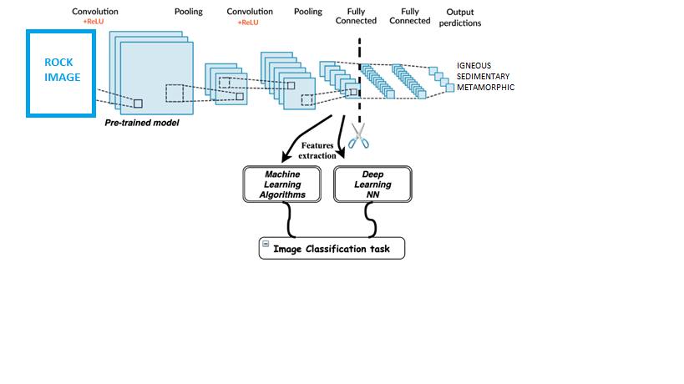

**5. Result:**

The following outputs are viewed using developed deep convolutional neural network.

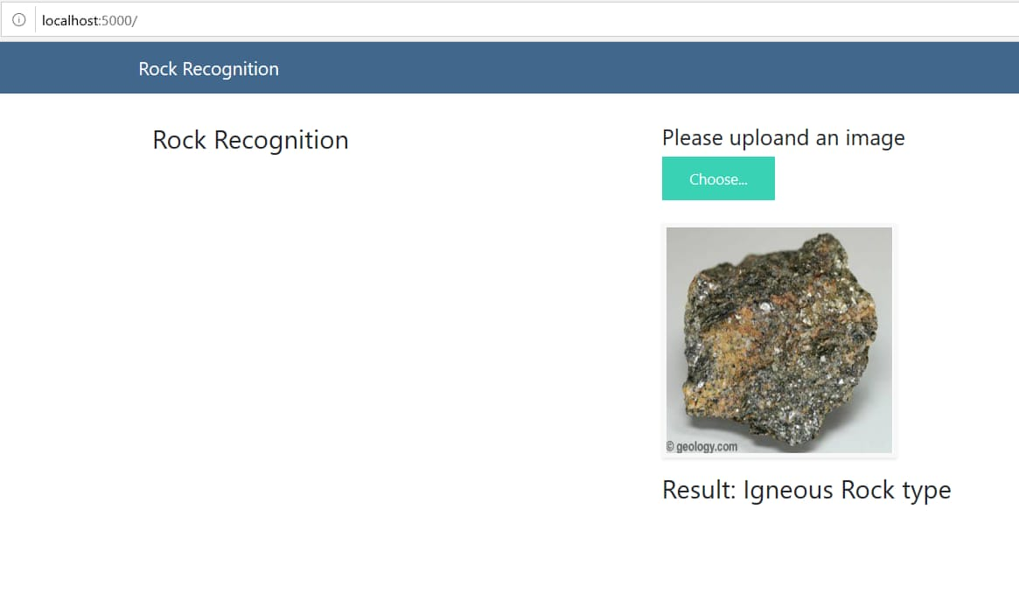

**6. Advantages & Disadvantages:**

Advantages:

* Reduces the waste of human resource for such busy work. The personnel can be assigned some other task.
* There is virtually no chance for error if the quality of image is high.
* Accurate output is obtained.

Disadvantages:

* There is obvious loss of jobs.
* There should be very high pixel quality images.
* We should avail the whole database of rock characteristics.

**7. Applications:**

Rocks are a natural solid substance. From building to highways- we can find the rocks almost everywhere. The robustness of rocks has played a significant role in everyday life.

1. Rocks are used for masonry work, lintels, and vertical columns, covering floors of the building.
2. Flags or thin slabs are used for paving, roofing, etc.
3. Broken or crushed rocks are used as aggregates in [concrete](https://civiltoday.com/civil-engineering-materials/concrete/270-concrete-definition-components-types), in road constructions.
4. Broken or crushed rocks are also used as railway ballast.
5. Stone screenings are used as a natural substitute for [sand](https://civiltoday.com/civil-engineering-materials/sand/233-sand-composition-types).
6. Limestone is the basic material for the manufacture of lime concrete and [cement](https://civiltoday.com/civil-engineering-materials/cement/81-cement-definition-and-full-details).

**8. Conclusion:**

Thus the project can be used in identification of rock types in order to get accurate result using developed deep convolutional neural network without the need of any human intervention

**9. Future Scope:**

As stated under applications, the project can be extended any other kinds of identification as well making it useful in any kind of situation where a specific accurate output is required.

**10. Bibliography:**

1. Singh N., Singh T.N., Tiwary A., Sarkar M.K. Textural identification of basaltic rock mass using image processing and neural network.

2. Młynarczuk M., Górszczyk A., Ślipek B. The application of pattern recognition in the automatic classification of microscopic rock images.

3. Ślipek B., Młynarczuk M. Application of pattern recognition methods to automatic identification of microscopic images of rocks registered under different polarization and lighting conditions. .